East West University

Lab03 Report

**Artificial Intelligence**

**Course Code:** CSE366

**Sec:** 02

**Submitted to**

# Dr Raihan Ul Islam

# Associate Professor

# Department of Computer Science and Engineering,

# East West University

**Submitted by**

Name: Tahrima Billal Biva

Id: 2020-3-60-049

Date of Submission: 16.12.24

# **Topic:BFS,DFS and UCS**

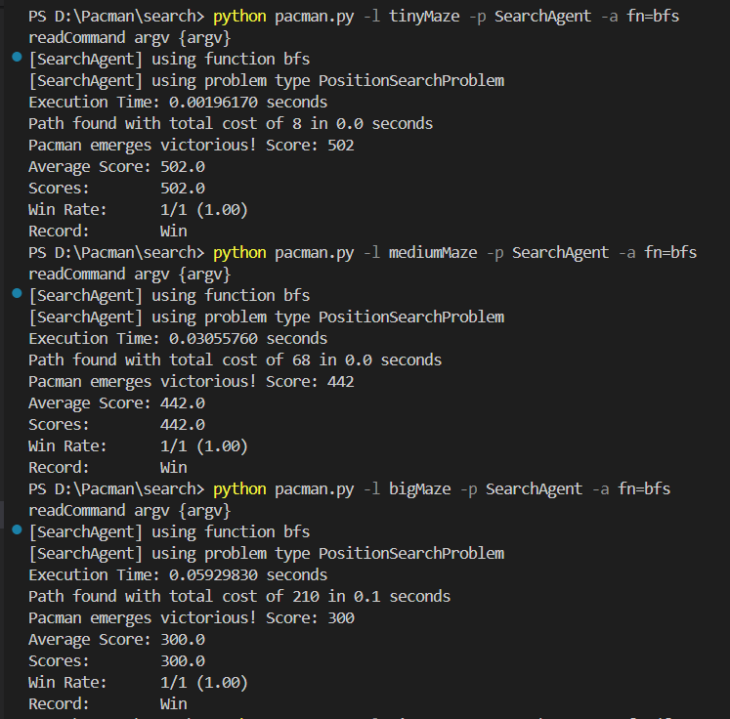

**Figure 1: BFS Execution of All Mazes**

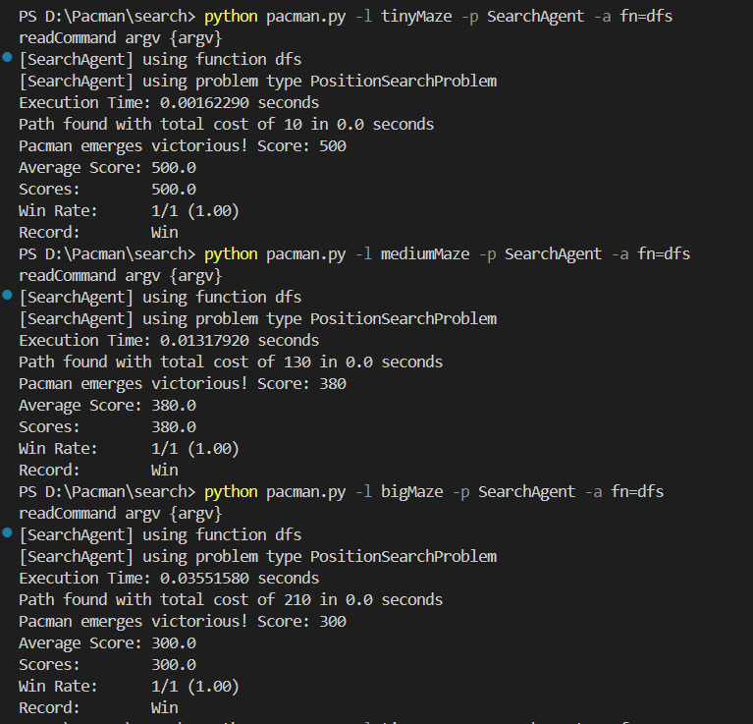

**Figure 2: DFS Execution of All Mazes**

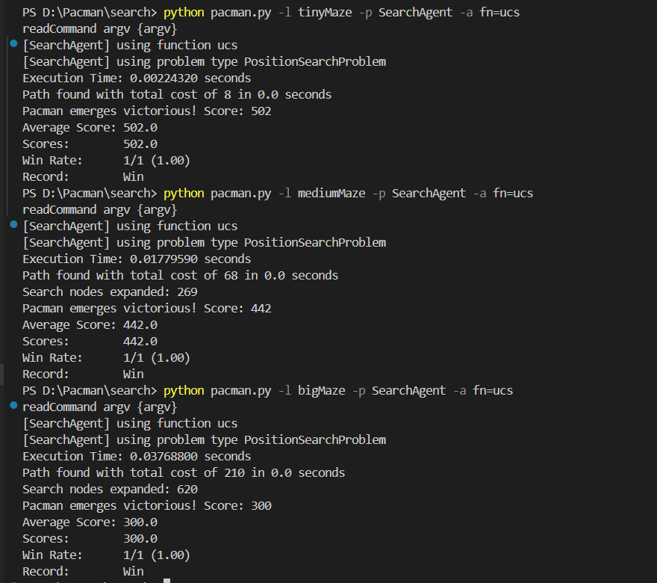

**Figure 3: UCS Execution of All Mazes**

| **Algorithms** | **Mazes** | **Path Cost** | **Nodes/**  **Path Expanded** | **Execution Time**  **(Seconds)** | **Total Time**  **(Sec)** |
| --- | --- | --- | --- | --- | --- |
| BFS | tinyMaze | 8 | 15 | 0.00196170 | 0.0 |
| BFS | mediumMaze | 68 | 269 | 0.03055760 | 0.0 |
| BFS | bigMaze | 210 | 620 | 0.05929830 | 0.1 |
| DFS | tinyMaze | 10 | 15 | 0.00162290 | 0.0 |
| DFS | mediumMaze | 130 | 146 | 0.01317920 | 0.0 |
| DFS | bigMaze | 210 | 390 | 0.03551580 | 0.0 |
| UCS | tinyMaze | 8 | 15 | 0.00224320 | 0.0 |
| UCS | mediumMaze | 68 | 269 | 0.01779590 | 0.0 |
| UCS | bigMaze | 210 | 620 | 0.03768800 | 0.0 |

Here, Execution time defines measuring the total time spent executing the specific search algorithm .And , the total time defines the additional time spent for the whole pacman game ,such as,loading , initializing , rendering graphics and processing the path etc.Nodes/Path Expanded defines number of nodes it has visited .Path cost define the total cost of the solution path.

**Comparison:**

For tinyMaze, the path cost of dfs is 10 while the path cost of bfs and ucs are 8 .All three algorithms have the same number of nodes expanded which is 15 for tiny maze .Also, the execution time of dfs is lower than the other two algorithms.That means dfs is faster than the other algorithms because it visits less nodes than the other two.

For mediumMaze, the path cost of dfs is 130 while the path cost of bfs and ucs are 68 .The expanded nodes of dfs is 146 while the expanded nodes of bfs and ucs are 269 for medium maze .That means the expanded nodes of dfs is lower than the other two algorithms. Also, the execution time of dfs is lower than the other two algorithms and the execution time of bfs is higher than the other two algorithms.That means dfs is faster than the other algorithms since it visits fewer nodes.

For bigMaze,All three algorithms have the same amount of path cost which is 210.The expanded nodes of dfs is 390 while the expanded nodes of bfs and ucs are 620 for big maze.Also, the execution time of dfs is lower than the other two algorithms and the execution time of bfs is higher than the other two algorithms.That means dfs is faster than the other algorithms because it visits less nodes than the other two.

In conclusion ,dfs is best based on the path costs,expanded nodes and execution times among all three algorithms for all mazes.